Name:___________________________________________________ Period:_____
Persepolis—Reading Assessment
Explain how graphic novel elements impacted page 29 in the story: (e.g., layout, panel, frame, gutter, bleed, foreground, midground, background, graphic weight, captions, speech balloons, thought bubbles, hands and feet).
Label 3 important graphic novel elements that impact the page below and explain why the author might choose to write/illustrate it this way.

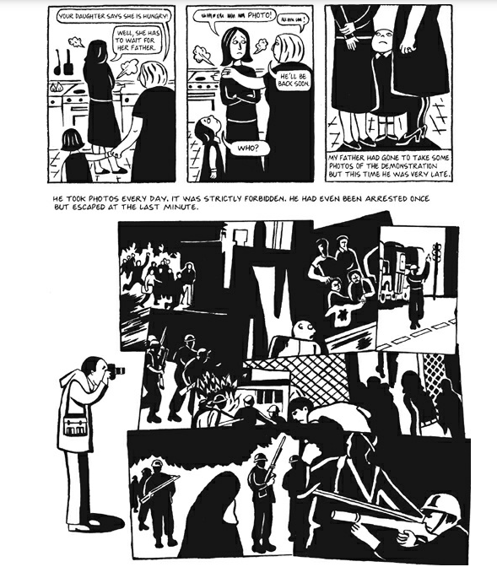

Name: _________________________________________________ Period ______
Literary Analysis Questions—Answer using CER (claim, evidence, reasoning)
- What are three critical events of the story Persepolis? What makes them important to the characters or plot?

- What type of story (genre) is the graphic novel Persepolis? How does the format/style influence the storytelling?

- Pages 70-71 are very significant to the story. What effect do the text and illustration have on the reader?
(i.e. What is happening in these panels and why is it significant? How does the author portray certain information? Does this section speech up or slow down the story and how? What emotions does it evoke?)

Stylistic Analysis Question—Answer in your own words (CER not required)
- What do you think the author hoped you would think after reading the text?

- What would you change in this text if you could write/draw/design it? Why?

Name:_____________________________________ Period:_____
Persepolis—Writing Assessment
Graphic novels can have an added impact on readers that a normal book cannot. What are some of those impacts? Why do you think the author, Marjane Satrapi, chose graphic novel form instead of a normal text?
Explain using multiple pieces of evidence from the book and include in-text citations (Satrapi 4).
________________________________________________________________________________________________________________________________________________________________________________________________________________________________________________________________________________________________________________________________________________________________________________________________________________________________________________________________________________________________________________________________________________________________________________________________________________________________________________________________________________________________________________________________________________________________________________________________________________________________________________________________________________________________________________________________________________________________________________________________________________________________________________________________________________________________________________________________________________________________________________________________________________________________________________________________________________________________________________________________________________________________________________________________________________________________________________________________________________________________________________________________________________________________________________________________________________________________________________________________________________________________________________________________________________________________________________________________________________________________________________________________________________________________________________________________________________________________________________________________________________________________________________________________________________________________________________________________________________________________________________________________________________________________________________________________________________________________________________________________________________________________________________________________________________________________________________________________________________________________________________________________________________________________________________________________________________________________________________________________________________________________________________________________________________________________________________________________________________________________________________________________________________________________________________________________________________________________________________________________________________________________________________________________________________________________________________________________________________________________________________________________________________________________________________________________

Enduring Skill: Reading
4 - Advanced | 3 - Proficient | 2 - Partially Proficient | 1 - Still Developing
In addition to proficiency, I can develop innovative connections by synthesizing information beyond the text. | I can comprehend, evaluate, and/or analyze texts meeting all success criteria. | I can comprehend, evaluate, and/or analyze texts meeting some success criteria. | I attempt to comprehend, evaluate, and/or analyze texts meeting limited to no success criteria.

Supporting ELOs: Reading Analysis (R.8 a/b)
Learners will:
- Analyze literary elements and how they impact the meaning, using textual evidence to support the analysis.
- Analyze how literary elements develop, interact with other elements, and advance the plot or develop the theme(s).
- Analyze how the character or author's point of view is influenced by outside factors and how it affects the telling of a story.
Success Criteria  (*need all for proficiency) | Concepts for Practice & Opportunities for Feedback  How can I improve and develop my skills? I can… | Student Reflection and Self-Assessment
Textual Evidence  + / – | - Incorporate accurate and relevant information  - Present evidence in direct quotes and/or paraphrases
Literary Analysis  + / – | - Evaluate how literary elements (e.g., layout, panel, frame, gutter, foreground, midground, background, speech balloons, thought bubbles, captions, hands and feet, shading, color) are critical to the text  - Evaluate how the author’s choices impact the audience and story

